THE FUNDAMENTAL PROPERTIES OF TOROIDAL CURRENT STRUCTURES.

First of science We show the existence of an external magnetic field and internal structure
the magnetic field in toroidal structures with a poloidal current.
Eugene Aleksandrovich Grigor’ev, Russia, 198412, St.-Petersburg
, Lomonosov, Krasnogo Flota st., 5-20.
E-mail: eugene-53@mail.ru

In January 2000, made a scientific discovery - the first time in electrodynamics numerically calculated and experimentally measured external magnetic field (MF) conductive toroidal structures with a poloidal current (Fig.1). Earlier, in classical electrodynamics, it was considered impossible. The history of the discovery and its implications can be found on the websites http://thermonuclear.narod.ru and http://thermonuclear.ru Arrows labelled i, shows the vectors of the elements of the current. The toruses was considered with a ratio R / r ≈ 1 and R / r ≈ 2. The calculation results are displayed in graphs Cantor. The lines on the charts show the cross section of surfaces of equal tension of the MF. The graphs – in relative units
The direction of the intensity vector, MF is perpendicular to the image plane, as lines of force MF are purely azimuthal (or tangential or tangent to the circle that lies in the XY-plane and centered on the Z-axis) component.
First calculate the magnetic field inside the torus
The torus with the relation R / r ≈ 1 (Fig.1).
Fig.1

Fig.2

The torus with the relation R / r ≈ 2 (Fig.3).

Fig. 3

Fig. 4

In the graphs (Fig.2, Fig.4) shows that the structure of the MP inside the torus does not correspond to the structure of MP infinite direct conductor with a current was believed to be still in the classical theory of electromagnetism. This structure conform to the field, created by a separate current element, located in the center of the torus to its major axis and directed along this axis. The schedule of this MP is shown in Fig. 5.
Fig. 5

Then, we calculated the external MF outside the torus in the XZ plane, in its part Y`(see Fig.3).
Fig. 6
The tension of the MF in the plane Y' (y = 0) in a graph of the Cantor.

Fig. 7
The tension of the MF along the line L - L; [ y = 0, x = const, B = f(z) ].

On the chart (Fig.6) shows that external MF torus exists. The graph in Fig.7 detects the feature of this MF three extremum and a double zero. Similar to the MF measured experimentally. The system enters a state with the minimum flux (minimum-energy) and becomes stable.

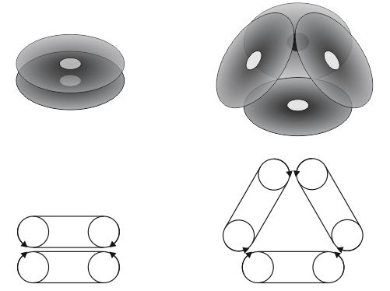

Возможный механизм образования атомного ядра из тороидальных частиц.
A possible mechanism for the formation of an atomic nucleus from toroidal particles.

The calculation of the external magnetic field created by the system of two coaxial tori and between them (Fig. 8) shows that it has a minimum of three coordinates in the center of the system and a tension growing in the direction from the center of the curvature of the force lines (Fig. 9). All this shows the futility of confining the plasma to internal MFs in closed traps with toroidal configurations of the Tokamak and Stellarator type MFs - retention is possible only in an open plasma trap by an external MF in any system of two coaxial tori of arbitrary configuration. Similar MF measured experimentally. Calculations also show that a short (0.1-0.5 m) plasma jet with a temperature of 100 million degrees and a speed of 10,000 km / s, which can be directly used in both underwater and aerospace vehicles, will fly out from the center of such a system along the Z axis. and after cooling to technologically acceptable temperatures (the free path of an α-particle with an energy of 2–4 MeV in air — 4–9 cm) is converted into mechanical work using anaerobic and high-performance STIRLING engines. This is a new world energy.
Thermonuclear know-how disclosed on the site http://thermonuclear.ru/treg_r.html
r
R
Y
X
ϕ
θ
Z
r
ϕ
θ
d
Fig. 8

Fig. 9
The previous calculations were made for continuous current carrying surfaces. Now let's make calculation for a torus consisting of separate rectangular coils with a current (a segmented torus) Fig.10, Fig.11. This is done to check the ability to play MF solid torus field is segmented (real) torus. Similar to the MF measured experimentally.
Fig. 10
Fig.11
The structure of the external magnetic field of a segmented torus in the plane Y' (XZ) in the form
of a graph of the Cantor.
Shows cross section of level surfaces of equal tension of the MF.
The intensity vector is directed perpendicular to the plane of the drawing.

Сегодня, благодаря моему начинанию, многие учёные теоретики и экспериментаторы стали исследовать тороидальные структуры, вихревое и вращательное движение и им откроются эти тайны.

Today, thanks to my undertaking, many scientific theorists and experimenters began to explore the toroidal structures, the vortex and rotational motion, and these secrets will be open by them.

